**POD Process workflow**

**Requests need to raise :**

<https://carms.nsiam.vzwnet.com/>

1. EDN workstation access

i. EDN Workstation Access

ii. EDN Account for Application Access

2. <https://webtools.verizon.com/> >> ADOM >> ADOM GROUP SEARCH

3. Atoll user access

SDLC_GYDV_GIT_DEVELOPER

4. Atoll tickets are created at this location

https://atyourservice.verizon.com/ays?id=support HYPERLINK "https://atyourservice.verizon.com/ays?id=support&ci=6e88edf4db4a53487e09feb5ae961988&kb_number=KB0030229 --> Create An Incident

| Projects | Git lab repo |
| --- | --- |
| Atoll on demand UI | https://gitlab.verizon.com/Network_Planning_Platform/atollondemand |
| Atoll on demand backend | https://gitlab.verizon.com/Network_Planning_Platform/atoll-on-demand-backend-engine |

Atoll on demand UI Server : <http://10.194.198.57:10533/atoll/>

To start the atoll UI server : Clone the repo to the linux server machine using winscp to [10.194.198.57](http://10.194.198.57:10533/atoll/), then check the port and host in aod.py and run ./run.sh in the command prompt. You can see server will be running [http://10.194.198.57:10533/](http://10.194.198.57:10533/atoll/) and log will be written in aodlog.txt

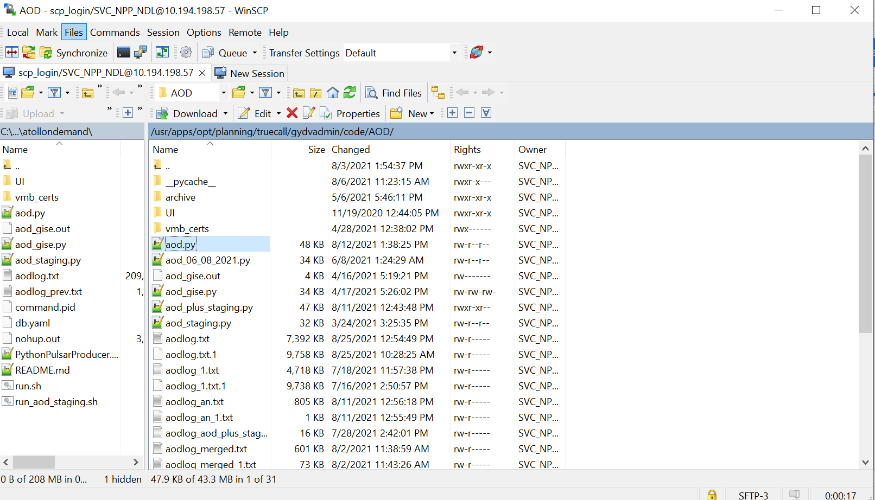

Atoll on demand backend : ondemand.py [ will be running in Virtual boxes ]

If multiple developers are working on test server which is as of now **txslatollpa72v.win.eng.vzwnet.com** in their respective workspaces

Atoll can be run by the command python ondemand.py --test

in that way atoll opens in the respective developer workspace instead of the server itself

Virtual boxes Computer names :

| Computer name | User name |
| --- | --- |
| txslatollpa70v.win.eng.vzwnet.com | win-vzwnet\username product_name_queue_custom |
| txslatollpa71v.win.eng.vzwnet.com | win-vzwnet\username |
| txslatollpa72v.win.eng.vzwnet.com | win-vzwnet\username - product_name_queue_test, |
| txslatollpa73v.win.eng.vzwnet.com | win-vzwnet\username |
| txslatollpa74v.win.eng.vzwnet.com | win-vzwnet\username |
| txslatollpa75v.win.eng.vzwnet.com | win-vzwnet\username |
| txslatollpa76v.win.eng.vzwnet.com | win-vzwnet\username |
| txslatollpa77v.win.eng.vzwnet.com | win-vzwnet\username |
| txslatollpa78v.win.eng.vzwnet.com | win-vzwnet\username |
| txslatollpa79v.win.eng.vzwnet.com | win-vzwnet\username |
| Txslatollpa80v.win.eng.vzwnet.com | win-vzwnet\username |
| Txslatollpa81v.win.eng.vzwnet.com | win-vzwnet\username |
| Txslatollpa82v.win.eng.vzwnet.com | win-vzwnet\username |
| Txslatollpa83v.win.eng.vzwnet.com | win-vzwnet\username |
| Txslatollpa84v.win.eng.vzwnet.com | win-vzwnet\username |
| Txslatollpa85v.win.eng.vzwnet.com | win-vzwnet\username |

**Process to login to VM box:**

1. Request for Remote Desktop Manager from <https://webtools.verizon.com/>
2. Login to Remote Desktop (RDP) by giving any of the above Virtual box name , username and password.
3. You can see in one of the command prompt ondemand.py will be running.

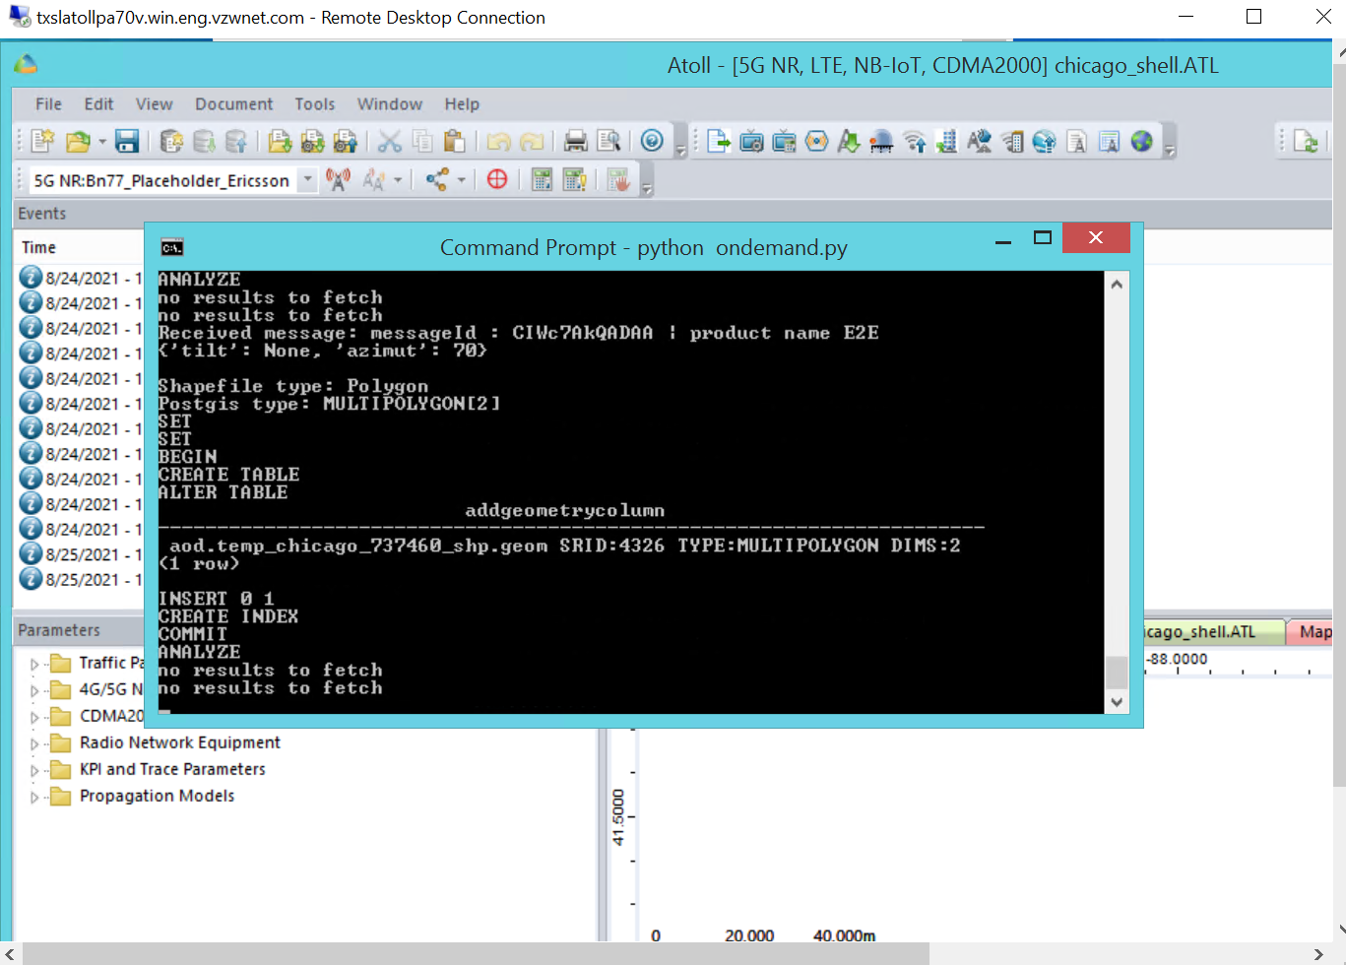

**Atoll on Demand API end points :**

1. <http://10.194.198.57:10534/atoll/coverage_request>
2. <http://10.194.198.57:10534/atoll/coveragerepeater_request>
3. <http://10.194.198.57:10534/atoll/coverage_request>
4. http://10.194.198.57:10534/atoll/coverage_status
5. <http://10.194.198.57:10534/atoll/atoll_methods>
6. <http://10.194.198.57:10534/atoll/coverage_refresh>
7. <http://10.194.198.57:10534/atoll/coverage_sitetxrequest>
8. <http://10.194.198.57:10534/atoll/coverage_reqthreshold>
9. <http://10.194.198.57:10534/atoll/coverage_bandrequest>
10. <http://10.194.198.57:10534/atoll/stage/coverage_request>
11. <http://10.194.198.57:10534/atoll/stage/coveragerepeater_request>

**Database Details:**

| **Database** | **Details** |
| --- | --- |
| **Nppcoverages (PostgreSQL) - Prod** | **For credentials refer configs.py file in gitlab link** |
| **NPP database (Oracle) - Prod** | **For credentials refer configs.py file in gitlab link** |
| **NDL database (Oracle) - Staging** | **For credentials refer configs.py file in gitlab link** |
| **GWYVLATI – for** shp2pgsql -shapefile upload  **(GIS data)** | **For credentials refer configs.py file in gitlab link** |
|  |  |

**AOD Process:**

**Step 1 :**

Starts from requesting the coverage data by hitting the url in postman: <http://10.194.198.57:10534/atoll/coverage_request>

With input sample data (post url with json data)

**[**

**{**

**"tx_id":"013384 01 B5_10MHz_2560 RAINBOW (2-0000)",**

**"site": "0384 RAINBOW (2-0000)",**

**"market":"saltlake",**

**"request_type":"PSD",**

**"request_subtype":"",**

**"receiver_height":"5",**

**"user_id":"",**

**"output_request_list":[**

**{**

**"type":"Vector",**

**"SubType":".shp",**

**"Threshold":"-104",**

**"Legend":""**

**}**

**],**

**"modified_attributes":{**

**"XGTRANSMITTERS": {**

**"CALC_RADIUS": "64373",**

**"CALC_RADIUS2":"241000",**

**"CALC_RESOLUTION":"30",**

**"CALC_RESOLUTION2":"90",**

**"MAX_RANGE":"0"**

**}**

**}**

**}**

**]**

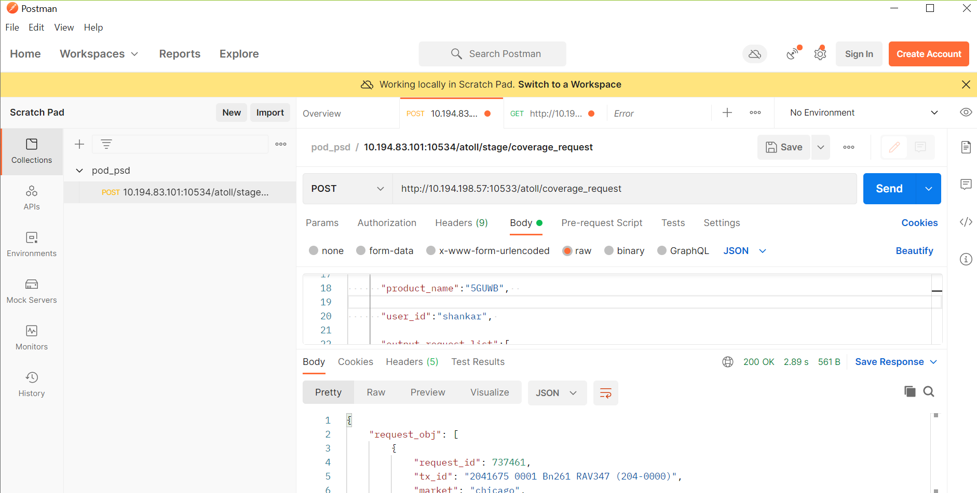

**Step 2:**

The link which we hit will be running from the server aod.py in the Linux machine with ip 10.194.198.57 and port 10533.

You can SCP to the Linux machine with your username and password (Should get from POD team) and see the server running there

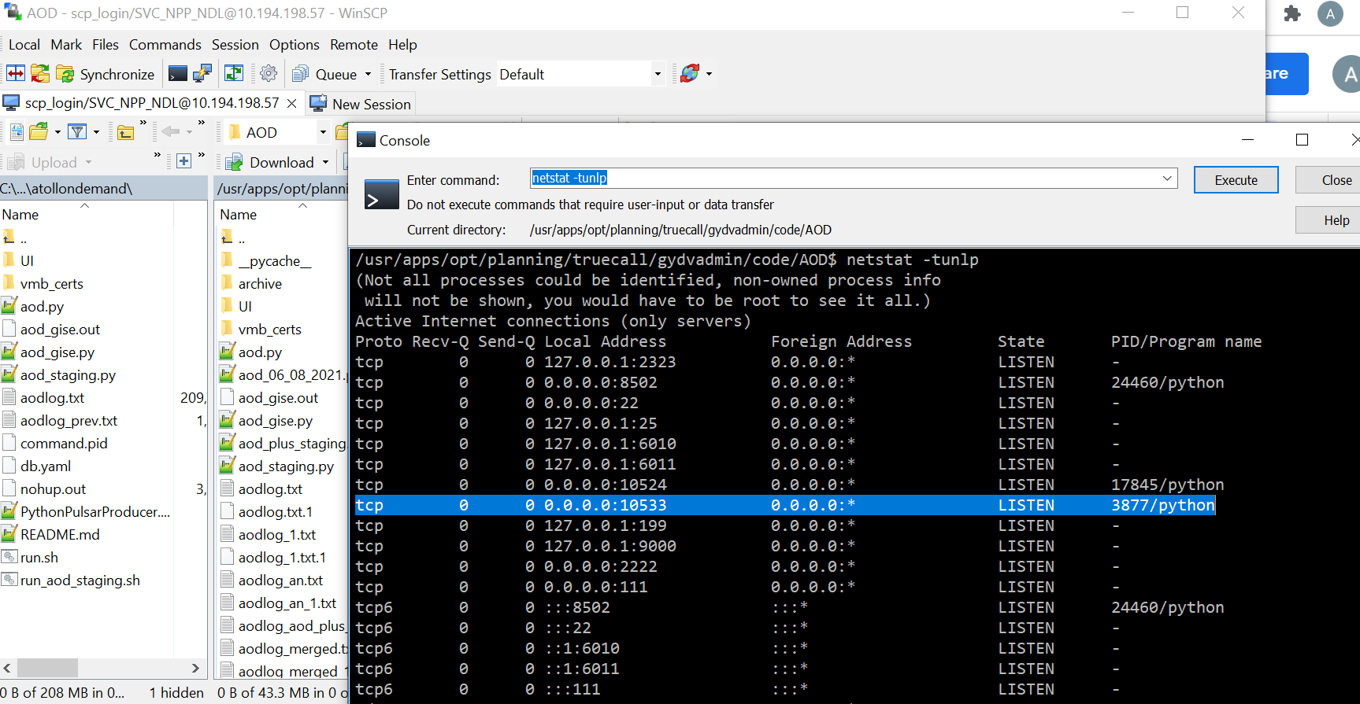

Technical details :

That link will call the function coverage_request() in aod.py which takes the input payload and extracts the required fields from payload and queries **(Q1)**  the NDL database and fetches other details for respective product names given in the payload. Product names - license_management_test, PSD_test, 5GUWB, ANTENNA_LOSS, LTE_test, DODC_test, DODC, UWB, E2E, pod-test, test, LTE

**Query (Q1):**

select Query:SELECT request_id,tx_id, market, site, request_type, request_subtype, status, cast(end_time-start_time AS VARCHAR) as proc_time from aod.transmitter_coverage_request where request_id = %s;

get sites:SELECT * FROM CAROLINAS.SITES where name = '0483 ASHEBORO64WEST (STA-0000)'

get tx:SELECT * FROM CAROLINAS.XGTRANSMITTERS x WHERE tx_id = '0483 0001-01 Bn5-B5 ASHEBORO64WEST (R-0000)'

get_cell_LTE:SELECT * FROM CAROLINAS.XGCELLSLTE x WHERE tx_id = '0483 0001-01 Bn5-B5 ASHEBORO64WEST (R-0000)'

get_cell_NR:SELECT * FROM CAROLINAS.XGCELLS5GNR x WHERE tx_id = '0483 0001-01 Bn5-B5 ASHEBORO64WEST (R-0000)'

**Step 3:**

Then inserts **(Q2)** and update the record in NPP database with status “SENT TO ATOLL / SENT TO ATOLL TEST” and returns the json output as shown below for above sample payload and logs the details in aodlog.txt where the server is running.

**{**

**"request_obj": [**

**{**

**"request_id": 731117,**

**"tx_id": "2041675 0001 Bn261 RAV347 (204-0000)",**

**"market": "chicago",**

**"site": "5580_3 RAV347 (STA-0000)",**

**"request_type": "public",**

**"request_subtype": "",**

**"status": "SENT_TO_ATOLL",**

**"proc_time": null,**

**"coverage_output": []**

**}**

**],**

**"meta": {**

**"status": "ok"**

**}**

**}**

**Query(Q2):**

Establishes connection to NPP database and inserts the coverage request record

INSERTINTO aod.transmitter_coverage_request(request_type,request_subtype,market,site,tx_id,user_id,status,product_name)values('RSRP','','ORLANDO','0081AMERICANSTAINLESS(STA-0000)','00810002-02Bn2-B2AMERICANSTAINLESS(2-0000)','FAILED_TX','SENT_TO_ATOLL','LTE')returningrequest_id;

Update Query:UPDATE aod.transmitter_coverage_request set atoll_request_object = (%s) where request_id= (%s);

**Step 4: This is where backend code will be executed.**

Ondemand.py is the Python script which will be running in all the VM boxes which will continuously share the traffic (coverage request hits) across the VM boxes.

Which will executes to functions :

req_prc.start() : Which will check the coverage_requests **(Q3)**

calc_prc.start() : Which will calculate the coverage data

req_prc.start() :

Triggers the rest.py get_request() function. It queries the aod.transmitter_coverage_request database and fetches the records with status “SENT_TO_ATOLL/FAILURE” with product names 'LTE', 'E2E', '5GUWB'. Fetches the required fields from the query results and passes to the MQ class function add_to_vmb.

**Query(Q3):**

**select \***

**from aod.transmitter_coverage_request**

**where**

**status in ('SENT_TO_ATOLL','FAILURE')**

**and product_name in ('LTE', 'E2E', '5GUWB')**

**and atoll_request_object is not null**

**and attempts < 3**

**order by**

**priority desc, market**

**limit 50**

**for update**

**Step 5:**

Once the add_to_vmb function is called, it will verify the SSL with the given certs(ca.cert.pem, gydv.cert.pem, gydv.key-pk8.pem) and sends the websocket message to Atoll using the product name producer details in cpmap.py. Updates the coverage_request record in NPPdatabase with status “ADDED_TO_QUEUE” **(Q4)**

**Query(Q4)**

**update**

**aod.transmitter_coverage_request**

**set**

**status = %(status)s,**

**{time} = %(timestamp)s,**

**comments = %(comments)s,**

**attempts = %(attempts)s**

**where**

**request_id = {req_id}""".format(req_id = req_id, time = time)**

**Step 6:**

Once the message is sent to ATOLL , calc_prc.start() this function will start executing.

calc_prc.start() :

This function triggers the Coverage.py script and calls the Coverage.run() function. Which will call the function receive_from_vmb(). It will receive the websocket messages(payload)/events with product name consumer details. Gets the request id and attempts from the event. Then updates the coverage_request record with status “PROCESSING_ATOLL” **(Q5)**

**Query 5**

**update**

**aod.transmitter_coverage_request**

**set**

**status = %(status)s,**

**{time} = %(timestamp)s,**

**comments = %(comments)s,**

**attempts = %(attempts)s**

**where**

**request_id = {req_id}""".format(req_id = req_id, time = time)**

**Step 7:**

Gets the active atoll objects and setup directories and paths for the object. Copies the atoll document and opens it. Extracts the required fields and adds the fields like site_info, cells and repeater info to the document. Calculates the antenna loss using function get_antenna_loss() where all the mathematical calculations will be done. Sets threshold, properties, receiver height, interpolation parameters, loss model parameters, prediction resolution and calculates the coverage data using function calculate_coverage(). Creates the vector folder using the function create_geom() and exports the bill_file using the function rssi_psd_create_geom_for_transmitter() . Copies the billfile in the raster folder and returns the raster file using the persist_raster() function. Then copies the raster file to EBS and updates the record with status “SUCCESS” **(Q6)**

**Query(Q7):**

**update**

**aod.transmitter_coverage_request**

**set**

**status = %(status)s,**

**{time} = %(timestamp)s,**

**comments = %(comments)s,**

**attempts = %(attempts)s**

**where**

**request_id = {req_id}""".format(req_id = req_id, time = time)**

**Step 8:**

When the user hits the api “/atoll/coverage_status” with request_id as payload, it will query the database with request id and return the json output of the calculated coverage data.

**Query(Q7):**

**"""SELECT status, comments from aod.transmitter_coverage_request where request_id = {request_id}; """.format(request_id=request_id)**